3D Adjustments



Table of Contents
Table of Contents 1
Introduction 2
Purpose 2
Scope 2
Overview 2
Step-by-Step Procedures 3
Revision History 3
Appendix 4
• Exhibit 1 – Open JE# sheet 5
• Exhibit 2 – Open Rumba_Wsf82r 5
• Exhibit 3 – open directory 5
• Exhibit 4 – open Form Name :1ctd 6
• Exhibit 5 – Select Current date 7
• Exhibit 6 – If no Data received. no need to do anything. 8
• Exhibit 7 – If received Data entry .we need to copy the Number of draft total amount
• Exhibit 8 –paste the value in Je# SHEET TO respective account and upload the JE# 12

Introduction

This is the function to book a JE from form “1CTD” for 3D Adjustment activity on daily basis.

Purpose
The purpose of this function is to appropriately account for 3D Adjustment activity and to create a journal entry to the respectively GL code for the Cash Account is 427.1088.05358 from form “1CTD”.

Scope
Frequency – Thrice in a month.

Overview
Select RUMBA “WSF82R “ Screen
Then Select the form "1CTD"
Then Select "M142XER“ Screen
Then Select “E1I “ Screen
Send the JE email to OA General Approvals
Stop
Find the Draft Account & Available in JE Template
START

No Yes

Create JE for the value belongs to Draft Account

Step-by-Step Procedures

Frequency – Thrice in a month.

- In the shared drive locate: \\winp-sfs-112\fss_general_accounting\Sutherland\2022\Claims.

- Create a new JE# sheet for the current date. (Exhibit 1)
- Copy pastes the Number of draft Totals. (Exhibit 2)
E1I - M142XER
FORM (1CTD) – Voucher Report
3.Email sent to OA Journal Entries. (Exhibit 3)

Revision History
Version 001 – Published on TBD
Appendix
Exhibit 1 _open JE# \\winp-sfs-112\fss_general_accounting\Sutherland\2022\Claims
Save as JE#
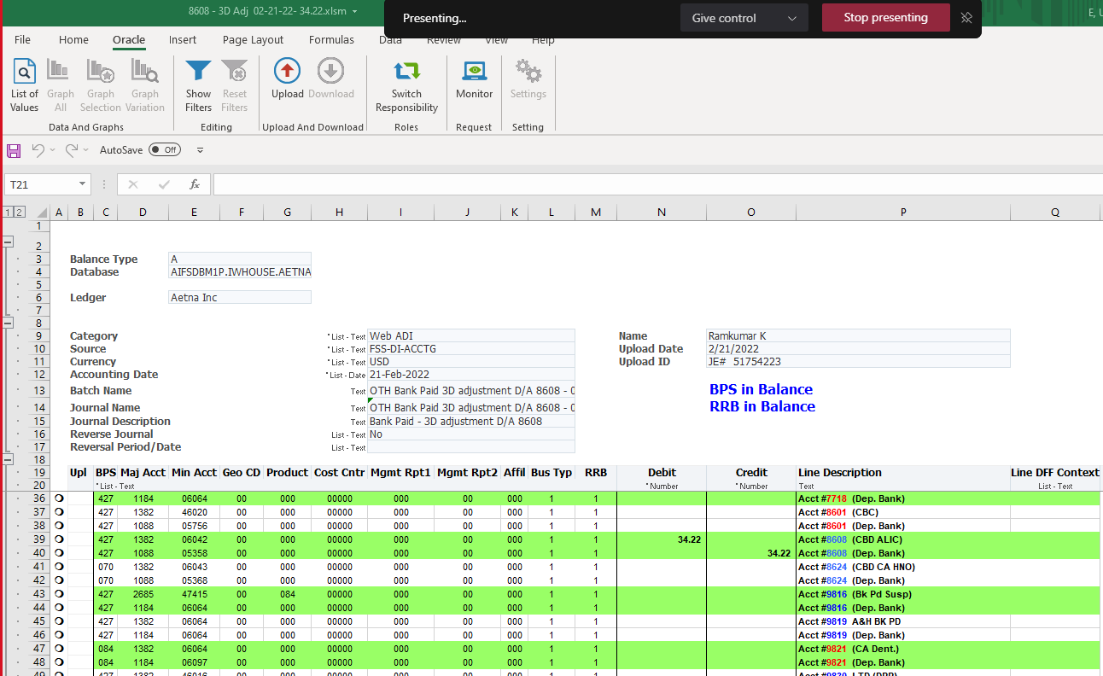 sheet with current date.

- Exhibit 2 – Open Rumba_Wsf82r

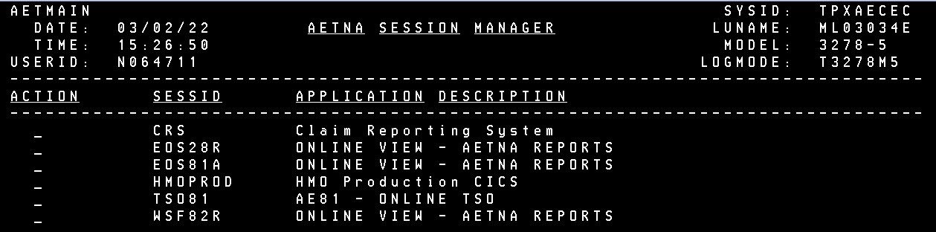

- Exhibit 3 -open directory E1I

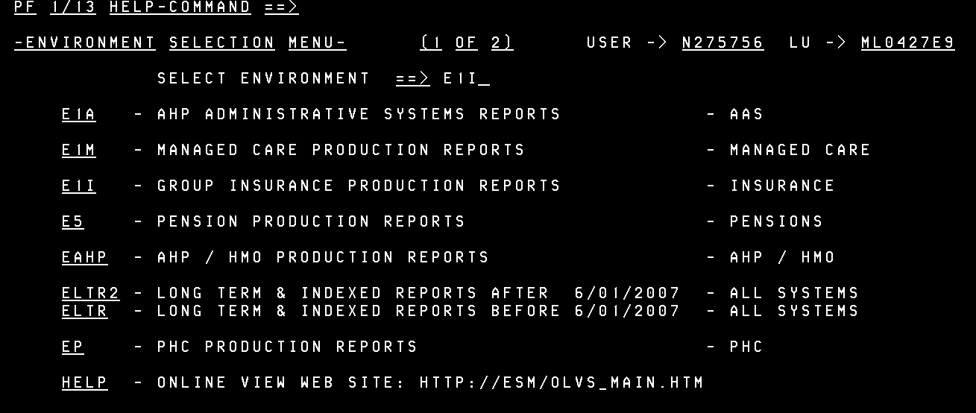
- Exhibit 3 -open directory E1I-M142XER

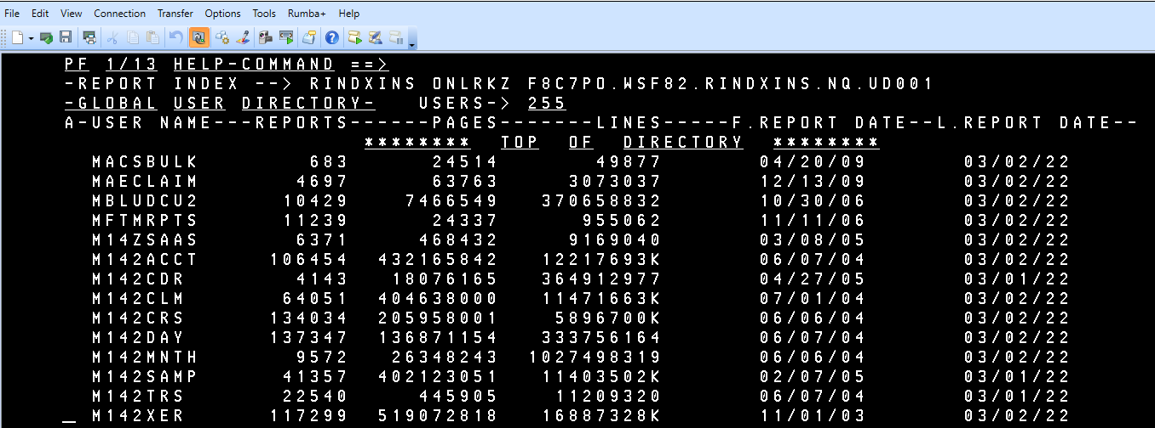
- Exhibit 4 – open Form Name :1ctd

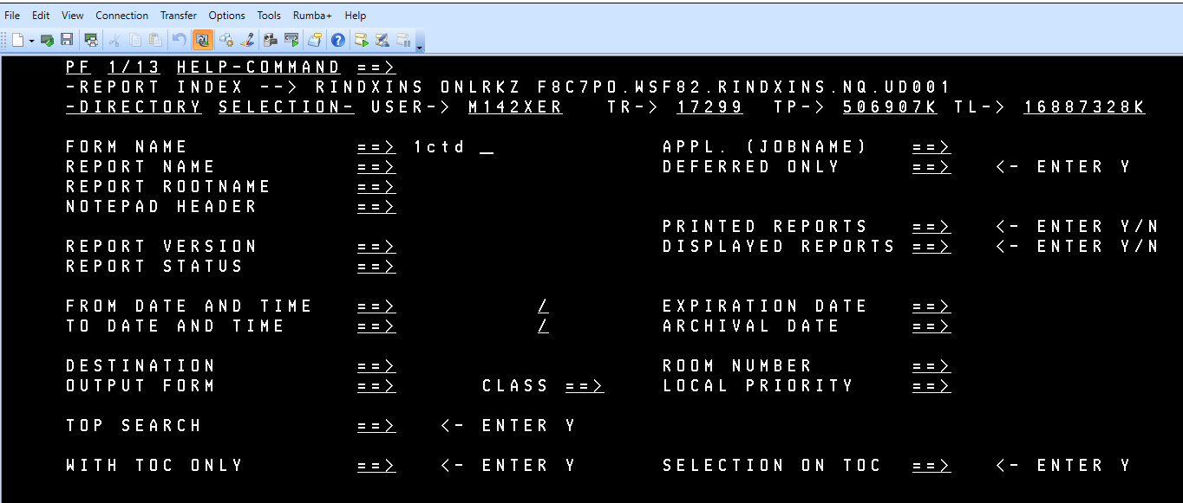
- Exhibit 5 – Select Current date

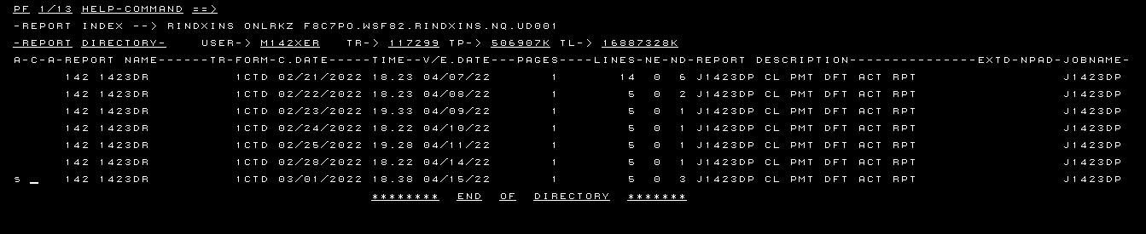
- Exhibit 6 – If no Data received. no need to do anything.

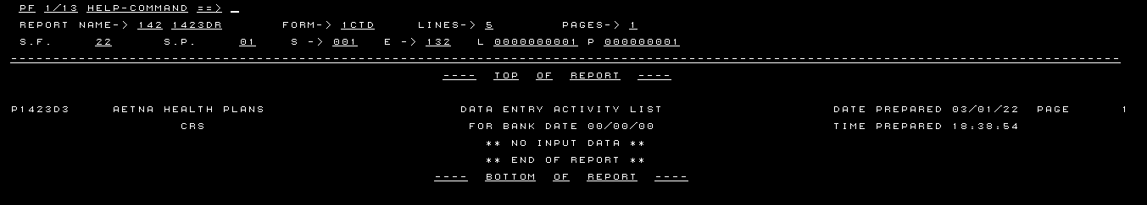

- Exhibit 7 – If received Data ENTRY. WE need to copy the Number of draft total amount. if there are draft accounts on the RUMBA report that are not on the JE template then those do not need to be journaled.

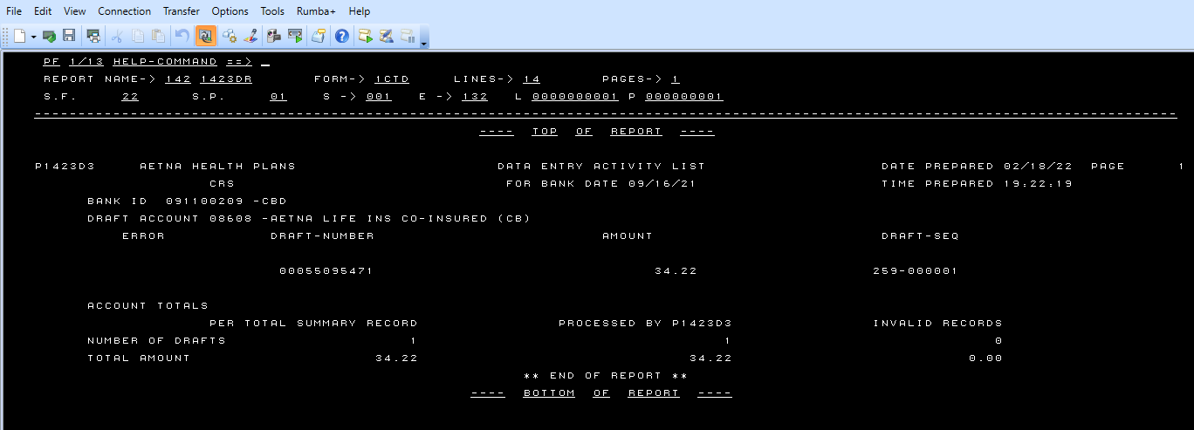
- Exhibit 8 –paste the value in Je# SHEET TO respective account and upload the JE#

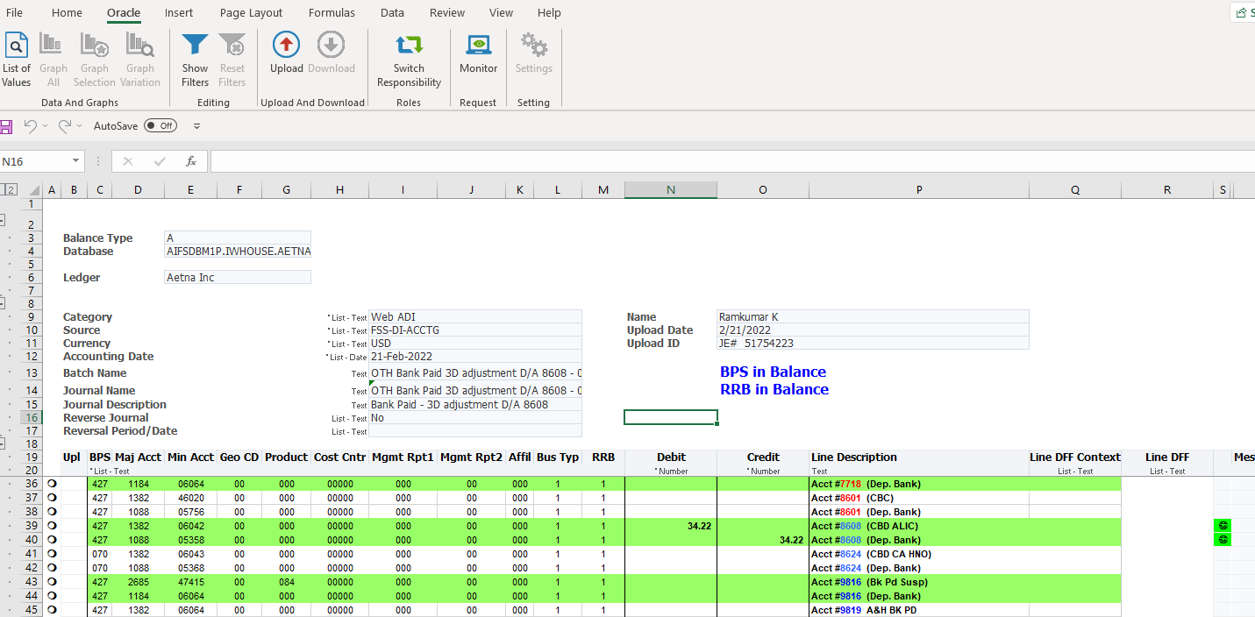

- Exhibit 9 – sent Je#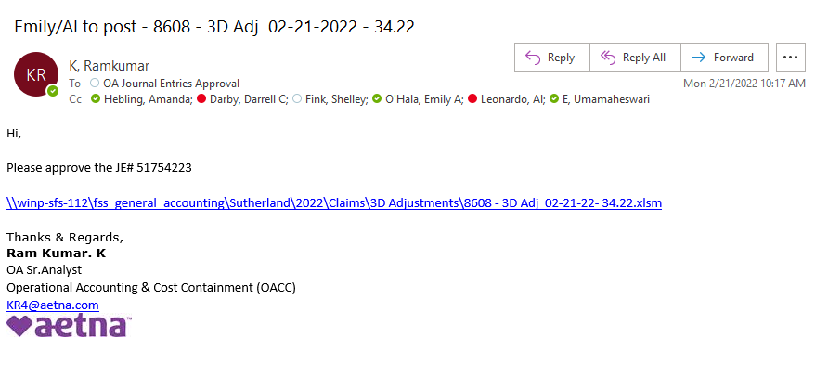 to OA Journal Entries Approval for approval.

END

