

PREMIUM REFUND VOIDS

PROCESS DOCUMENTATION
as of November 15, 2016
Approved By: (Manager)

Organization: Shared Services Controllership
Department: FIN Operational Accounting & Cost Containment (OACC)

Contents:
Go to | Process Owner and Backup
Go to | High Level Overview
Go to | Frequency & Time
Go to | Process Flow Chart
Go to | Systems and Access Needs
Go to | Source Data
Go to | Step by Step Procedures
Go to | Escalation Procedures
Go to | Downstream Impacts

Location of document:
Discuss Shared Drive location with your manager to save documentation+
\\winp-sfs-112\blbacctrcv\CAR Team\Process Documentation\Updated Format 2016\Premium Refunds

Tips for consistency:
If using acronyms, ensure you write them out
Use a consistent font and size, preference is Calibri 12pt

Modifying/Updating Procedures (Endnotes)
When modifying or updating your procedures, please add endnotes to that section indicating when the update was done and a summary of what was modified. Contact Manager for approval of change. Manager will note the date they approved the update in the Endnote. Ex. Updated: 10/13/16. Changed Backup Name. Approved by: Manager 10/13/16.
Endnotes are to be reviewed on a yearly basis and subsequently deleted after updates are common practice.
Endnote: To add an endnote, place your cursor on the area where the change was made, then select the references menu and select insert Endnote. This will take you to the end of the document where you can add your summary of the changes.
- Process Owner:
List the name of the person who currently owns the process and list associated people who are designated and trained as backups to the process.
Primary | Backup(s)
Sutherland

- High level overview of this function:
This is the function ‘at a glance’. The overview should include what the function is and why it is done.
These are premium refund voids where the refund check has been re-issued, therefore the original refund check issued needs to be voided.

- Frequency & Time:

Frequency  How often is the process performed? | Once a month
Time to Complete  How long does it take to complete each time? | 1 hour

- Process Flow Chart:
Draw a visual flow chart for the function. The diagram should include function inputs, processes and outputs. Hint: draw on paper before attempting to create a flow chart in Word.

- Systems Used & Access Needs:
List the systems, share drives, shared email boxes, databases, etc. that are required to perform this function. Also identify special access needs associated with performing the function.
EBS Oracle
Legacy Oracle
\\winp-sfs-112\blbacctrcv\Accounts Receivable\Cash Control Files\Accts Payable spreadsheets
\\midp-sfs-114\blbhmoprem\CRRegion\Batch Headers-cash batch header form VOIDS

- Source Data:
Explain what information is needed before the first step in this function can begin. Explain where the information comes from and how you obtain it.
Debra Beck from Trade Accounts will send an email once a month, around the 21st of each month

- Step by Step Procedures:
Include detailed procedures on how to complete this function. Include screenshots and links to websites, other documents and share drives where appropriate. Document any exception processes either within this section or add an appendix.

- Obtain the email from Trade Accounts Payable, received on or around the 20th of each month.
- This email will contain a report and pdf files
- Open the PDF Files
- The PDF files that have a corp code of 100, with a psu id number, are EBS Voids
- The PDF files that have an AE or US member id are Legacy Voids.

EBS VOIDS

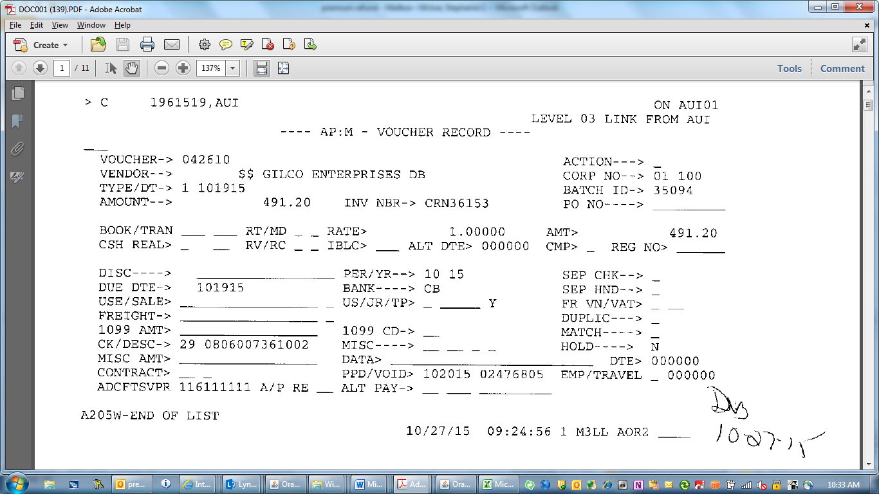
- Open each file, and note the amount, for example above, the amount is 491.20.
- Do this with each ebs pdf file.
- The best way to keep track is to open an Excel Document and type the EBS Voids in one column.
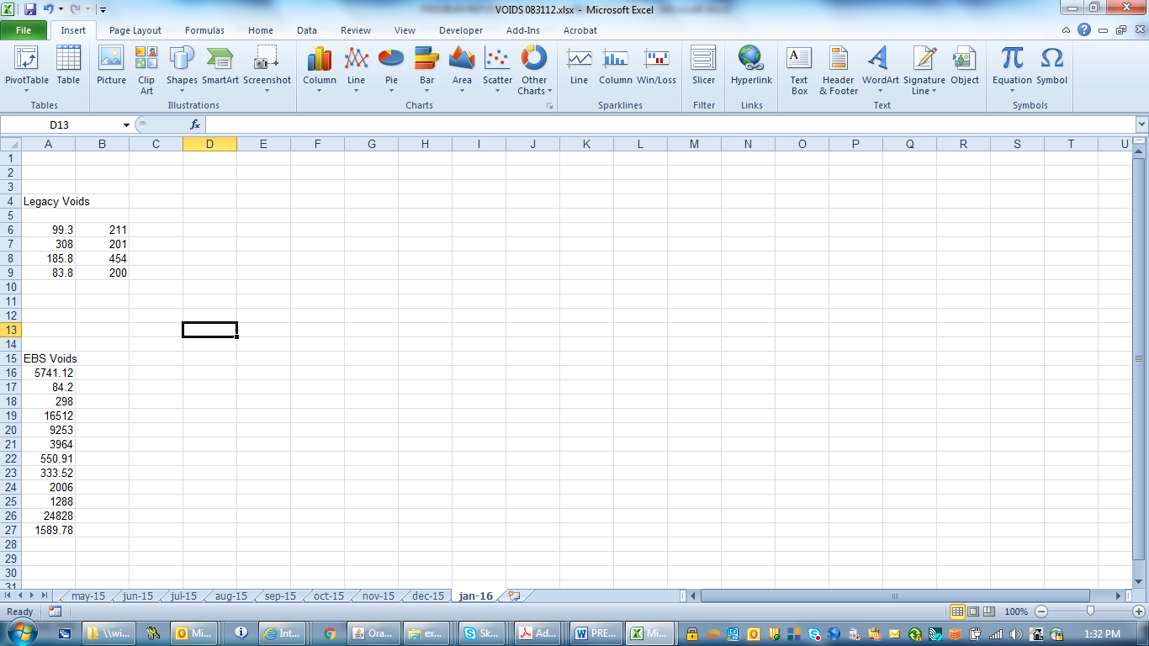

- Place all amounts on the Cash Batch Header for Voids under the EBS Voids Tab

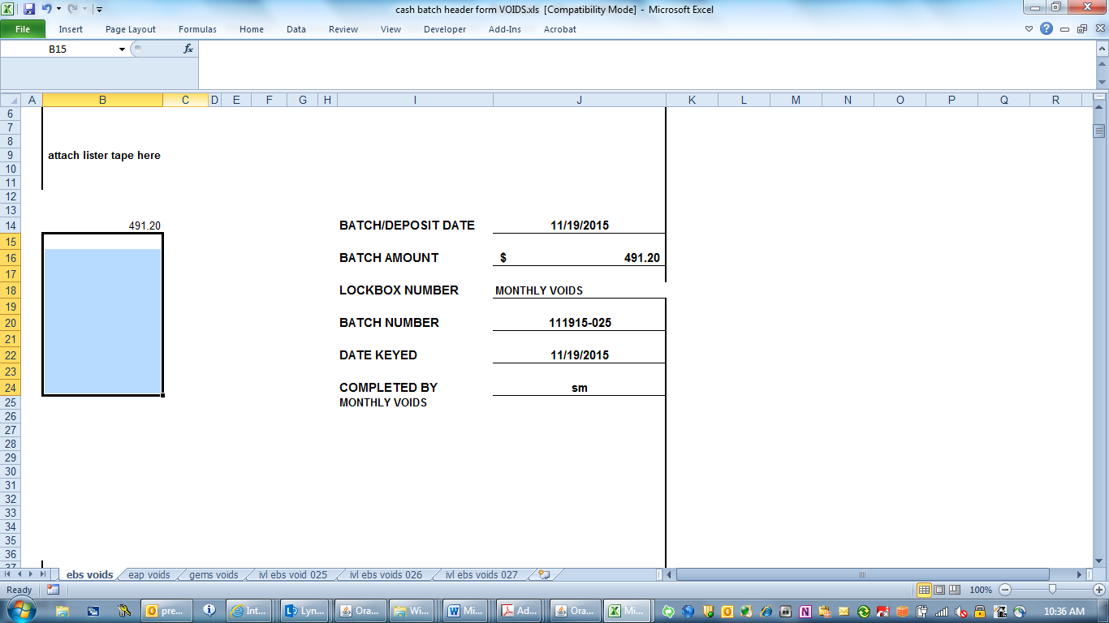
- All amounts are to be entered as a positive number on the cash batch header. Be sure to select the tab named EBS Voids
- Enter the batch date-which is the date you are processing
- Enter the batch number, also the date you are processing
- Enter the date keyed, also the date you are processing
- Open EBS Oracle, and open Transaction Batches
- Enter as noted below on the screen print
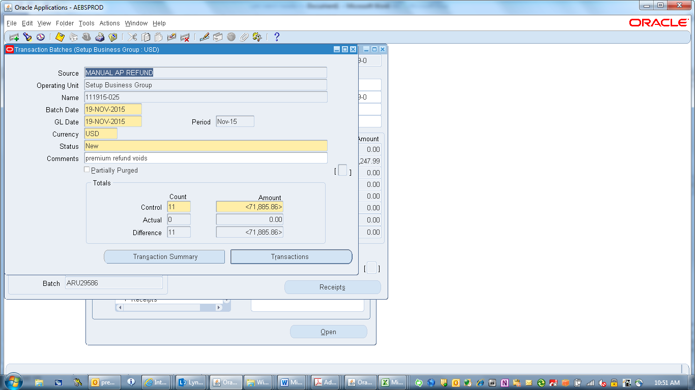
- Make sure the source is Manual AP Refund
- The control is to be entered as a negative amount, as these are voids.
- Save
- Once the batch is set up, now the voids need to be keyed.

PLEASE SEE INSTRUCTIONS AT THE END FOR KEYING VOIDS

LEGACY VOIDS

- Open the pdf files for legacy, and note the amounts. The best way to track the amounts is to keep an Excel file to separate ebs from legacy. For the legacy amounts, also indicate the corp number listed on the pdf file. Example below.
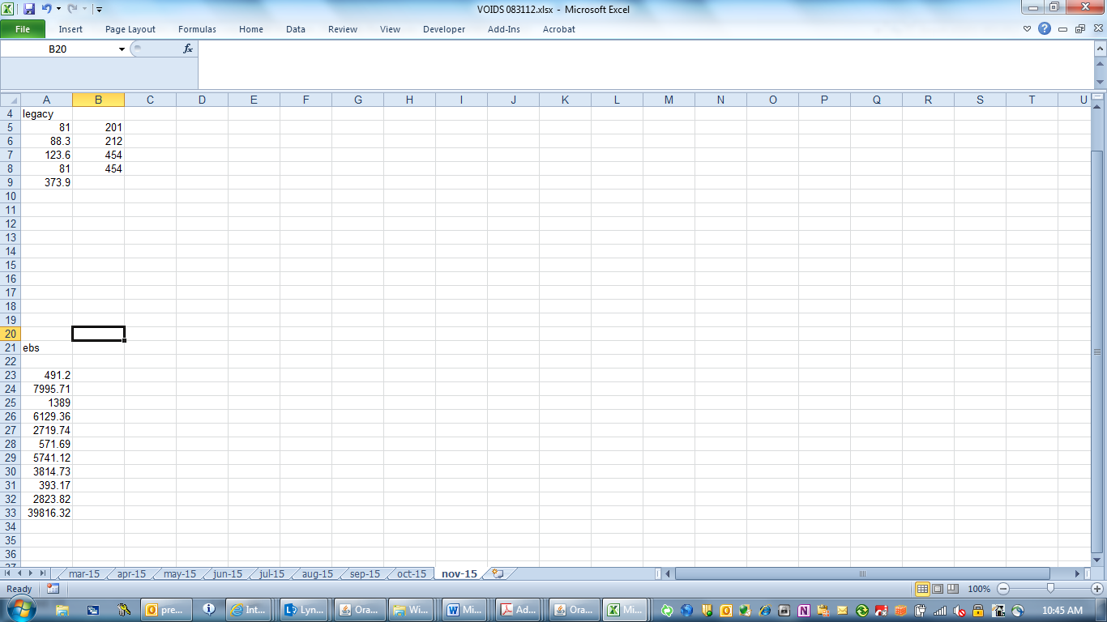
- The legacy voids will need to be Journal Entry, as the EBS voids do not.
- Using the same cash batch header, select the tab for Legacy Voids
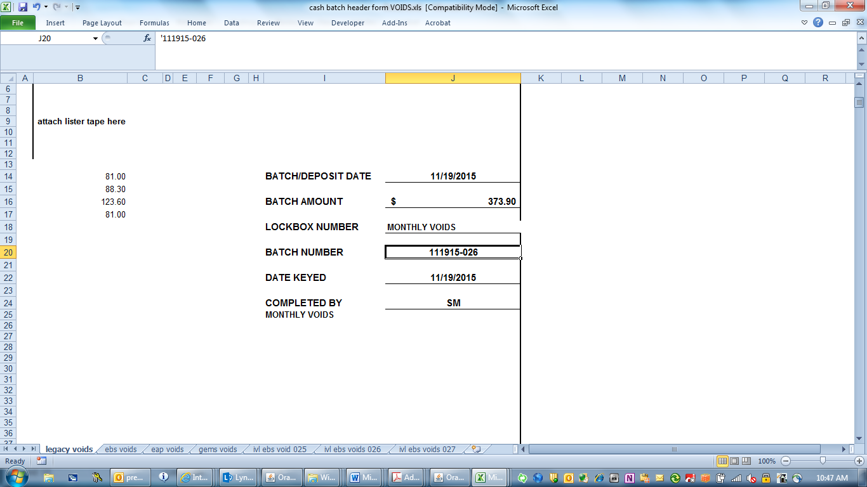
- Amounts are also to be entered as a positive number
- Enter the batch date-which is the date you are processing
- Enter the batch number, also the date you are processing
- Enter the date keyed, also the date you are processing
- Open Legacy Oracle and open Transaction Batches
- Enter as noted below on screen print
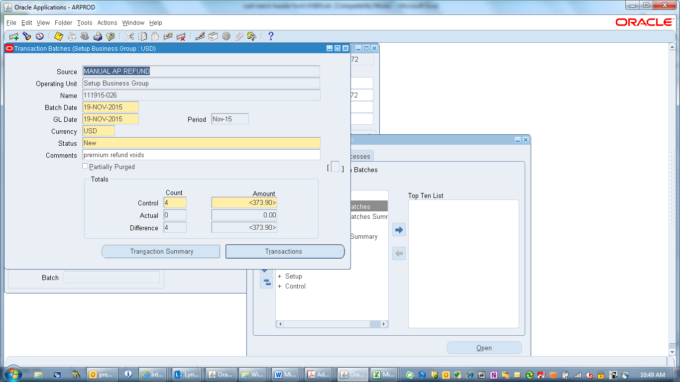
- Make sure the source is Manual AP Refund
- The control is to be entered as a negative amount, as these are voids.
- Save
- Once the batch is set up, the voids now need to be keyed.

KEYING VOIDS IN ORACLE

- Open the transaction batch
- Before keying any refund/void refund batches you must make sure that the “SOURCE” always says MANUAL AP REFUND. If it does not – PLEASE DO NOT KEY THE BATCH and contact whoever set up the batch to correct.
- Click the “TRANSACTIONS” button to open the batch.
- Your screen will look like the one below
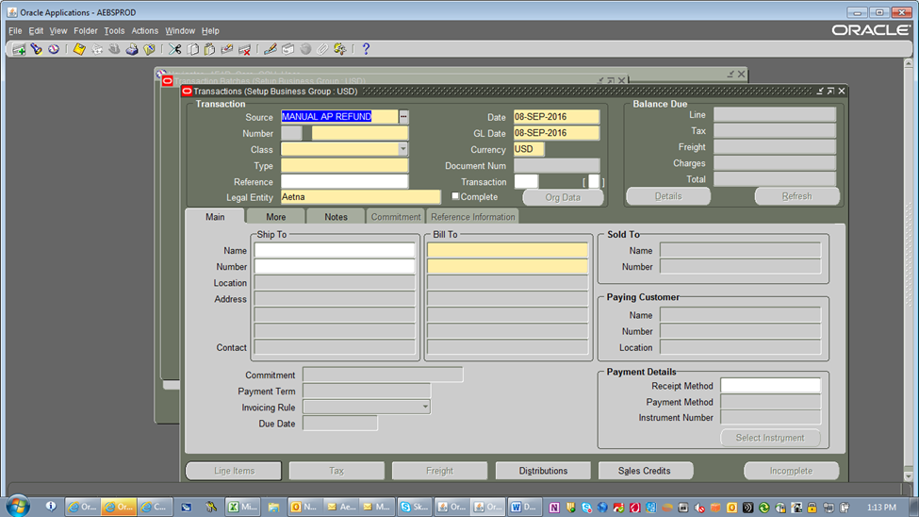

- Tab to the “DATE” field and change the date to the 1st of the month
- As will all refunds and voids refunds in EBS Oracle the “NUMBER” field is always the same – XXXXXXXX-XXXXXXX-XXX. An 8 digit number, followed by a 7 digit service, followed by VOI for void. Using the spreadsheet copy the REQUEST No./VOID SP information first, followed by a dash (-), then copy the service area from the spreadsheet, followed by another dash (-) and end with VOI.
- Tab to the “Class” field and click on the arrow to open the drop down box.
- Select Credit Memo.
- Tab 2 times until your cursor is in the “TYPE” field. Key the first 4 digits of the services and hit your TAB button.
- Select the information with “REFUND CM” not “NET ID CM” and hit the “OK” button.
- Hit the “TAB” key 3 times until INVOICE TRANSACTION FLEXFIELD appears
- In the “INVOICE GROUP” field enter the same information as the “NUMBER” field. Then key the last three digits in the service area in the “PRODUCT” field and hit the “OK” button
- The TRANSCATION INFORMATION screen will appear.
- Copy the information from the “BIC” cell on the spreadsheet and paste it in the BIC field on the TRANSACTION INFORMATION SCREEN.
- Click on the three dots in the PAYMENT METHOD field to open that field
- Tab 4 times until your cursor is in the “NUMBER” cell under “BILL TO”.
- Copy and paste the CGUID number from the spreadsheet and hit your TAB button.
- This fills in the customer’s information.
- Click the “LINE ITEMS” button.
- Under “DESCRIPTION” key the word “DEFAULT” (in all capital letters)
- Tab to the “QUANTITY cell and enter the #1
- And enter the amount of the void refund from the spreadsheet with a negative in front of the amount because this is a credit in the UNIT PRICE cell.
- See below – this is what your screen should look like.
- Hit the Save Button
- Exit this screen.
- You will now be back to the main screen
- Click on the “ORG DATA” button
- Under “ORG DATA” there are three cells you must fill in. In each cell there are three dots. Click the three dots in each cell and select the following
- ORG Name – 039934088 (AETNA)
- ORG Arrangement Name – 019200955 (Default Arrangement)
- ORG Type Name – MEHUS
- And hit the SAVE button.
- Exit this screen so you are back to the main screen.
- Click the COMPLETE button and it will change to “INCOMPLETE”
- Tab down to enter another Void Refund
- When you are finished all the Void refunds in the batch close the screen above and you will see the Batch Header screen again.
- The last step is an audit to double check and make sure the “complete” button was clicked.
- Open the TRANSACTION SUMMY button
- Scroll to the right using the scroll bar to make sure the transaction is completed.
- If the transaction is complete the batch is done.

Journal Entry for Legacy Voids

- The legacy voids need to have a Journal Entry submitted
Template for the voids JE is located here: \\winp-sfs-112\blbacctrcv\Accounts Receivable\Cash Control Files\Accts Payable spreadsheets\Premium Refund Voids
- Obtain the Premium Refund Void JE, as shown below-PLEASE NOTE THE TEMPLATE HAS HIGHLIGHTED YELLOW AS TO WHERE INFORMATION NEEDS TO BE ENTERED, PLEASE BE SURE TO REMOVE THESE HIGHLIGHTS WHEN SAVING.
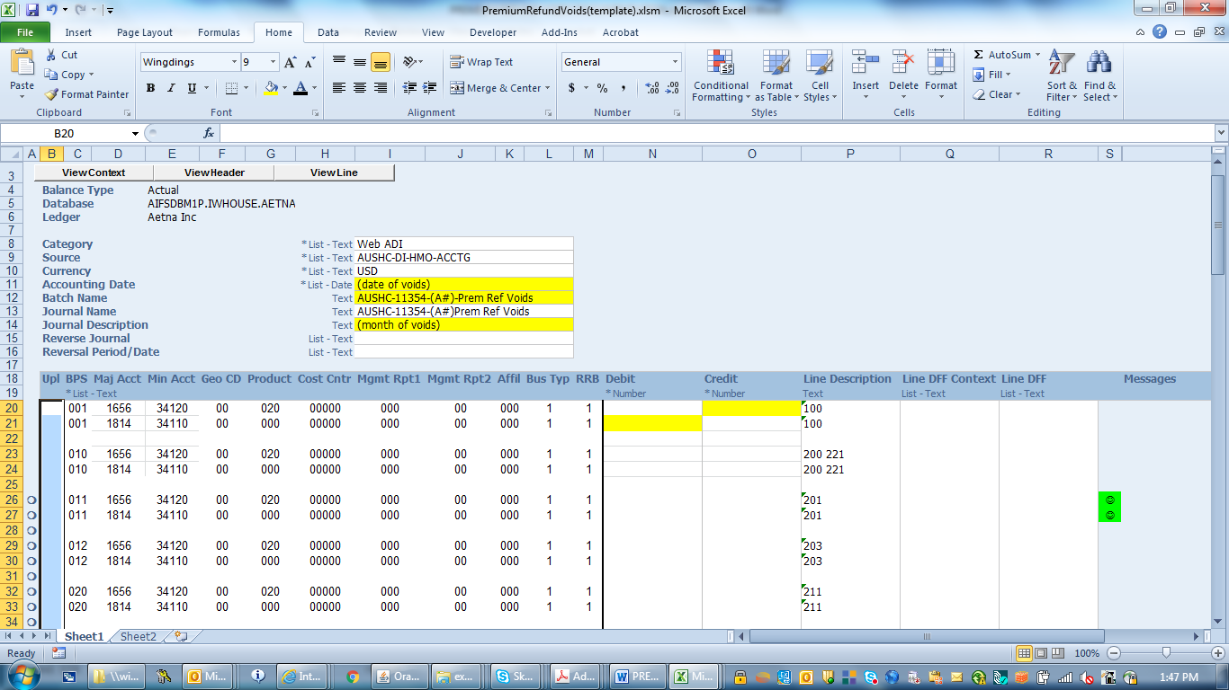
- Enter the date of voids, usually the last day of the month
- Be sure to enter your Aetna Number
- The month of the voids
- Refer back to the list compiled when going thru the PDF files
- Only the legacy voids need to be JE
- The Line Description refers to the corp code that is written on the pdf file
- The total of each corp code is to be entered on the voucher, the line description will guide you as to where to place the total
- For example, any Corp Code listed with a 200, will be entered on the JE under 010.
- Remember these are voids; the totals are to be entered as shown above, debit and then credit the amount
- Keep in mind, any 454 codes need to be entered twice on the voucher
- Once completed, upload the JE, note the JE number, and save.
- Send an email with the attached JE to and the APCB report that was received on the email from Trade Accounts. Premium Voucher Wire Approval Mailbox, Debra Beck and copy in Synitta Griffin.
- Example of email to be sent….

- For research purposes, save the email received from Trade Accounts to the following folder: \\winp-sfs-112\blbacctrcv\Accounts Receivable\Cash Control Files\Accts Payable spreadsheets\Premium Refund Voids\Trade Account Void Emails

- Escalation Process (if applicable):
Describe the process for escalating any issues that might arise while performing this function.
Examples: Does a variance need to be escalated, and to whom? Is source data missing or unavailable?

- Downstream Impacts:
Explain what happens after you complete the function. Describe other processes or areas that are impacted by the completion of this function.
Voids are placed on the refund checks that were re-issued.

